Project 9.3a(iii) Virtual Design Briefs (Antique Goblet Display Case)

Client: Sweeney & Meltzer Antiques LLC

Designer: __________________________

Problem Statement: Existing shipping containers for antique goblets provide protection while in transit but do not allow for easy viewing of the goblet. Existing display cases offer great visibility but do not protect goblets during shipping. The owner of an antique priceless goblet has agreed to allow the artifact to travel among museums only if the item will be protected and if people will be able to clearly see it.

Design Statement: Design a shipping container for an antique goblet that will protect the goblet during shipping but can also be used to give an unobstructed view of the goblet when it is on display. The case should be able to be modified on the inside to accommodate other goblets that vary slightly in size. Also the case should be designed to fit into a larger flight case that holds four (4) of the display cases.

Constraints:
- The container must accommodate the goblet provided by the client. The file has been provided for your use in the design (grail.ipt).
- The case must be made of 8 parts minimum, with each team member creating 4 parts minimum.
- The case must be assembled with simple joinery (no butt joints). Constraints do not count as joinery.
- The case should be designed to fit four (4) cases into the flight case provided by the museum. See photo at end of document.
- The case must have a device that holds the goblet secure when the case is open and does not obstruct the viewing of the goblet.
- The case must have a latch or locking mechanism to provide a secure closure while in transport.

Image of the Goblet (grail.ipt)
Goblet Specifications:
Overall Height = 7.59 inches
Base Diameter = 3.96 inches
Mouth Diameter = 4.97 inches

Image of Flight Case
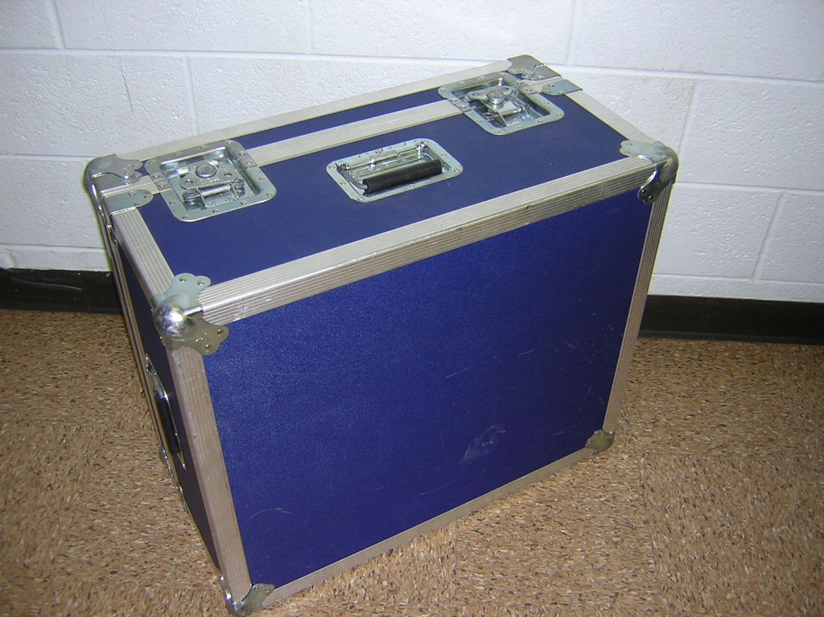
Flight Case Specifications
Exterior Dimensions  Height = 22.5 inches  Width = 26.75 inches  Depth = 13.5 inches | Interior Dimensions **  Height = 21 inches  Width = 25.25 inches  Depth = 12 inches
** These values do not include any interior case padding.

