Project 9.3a(i) Virtual Design Briefs (Modular Coffee Shop Table)

Client: Mr. Smith’s Coffee Shop

Target Consumer: University students 17-30 years old

Designer: __________________________

Problem Statement: The current lounge chair and living room-style seating areas in Mr. Smith’s Coffee Shop are too large and cannot accommodate the growing number of patrons.

Design Statement: Design and model a modular table that will allow a greater number of patrons to be serviced at Mr. Smith’s Coffee Shop.

Constraints:
      - Minimum of two (2) adults seating per table.
      - Modular table design must interlock for stability.
      - Maximum material costs are $200 per table.
      - Maximum weight limit of 50 lb per table.
      - Initial design concept is due in 1 week.

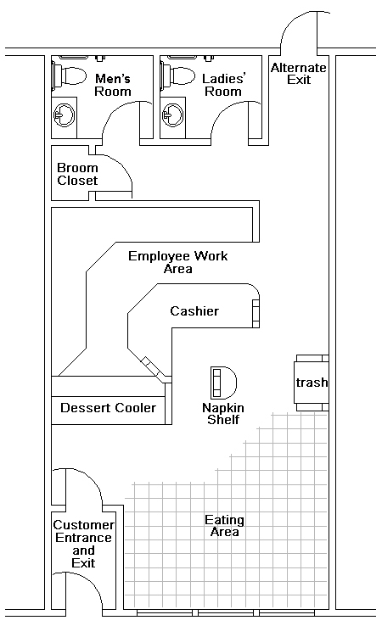

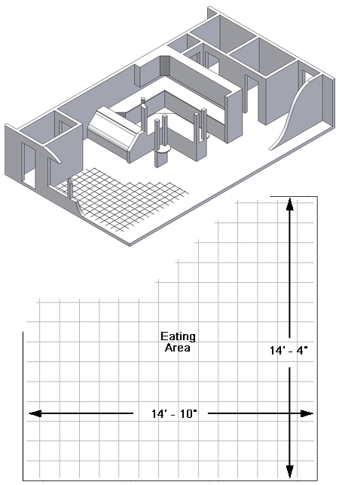
Note: Each tile is 12” x 12”

