Activity 7.3 Tolerances

Introduction
The term variation describes the degree to which an object or idea differs from others of the same type or from a standard. Examples of variation are everywhere you look. When you see yourself in the mirror, you notice the left side of your face is not exactly the same as the right side. There is a variation. Or, if you see identical twins, they are not exactly the same. Likewise, no two manufactured objects are the same. A degree of variation will exist.

The use of tolerancing in engineering design provides a means by which variance can be controlled within acceptable limits so that parts of a product fit together in a way that allows the product to function properly. In the field of mathematics and science, tolerances are used regularly. You will see reference to an allowance or tolerance given in many settings. After completing this activity, take note when you see tolerances given in the media or on product labels.

In this activity you will analyze engineering drawings, identify tolerances, explain the meaning and purpose of those tolerances, and calculate allowances between mating parts of a product. You will also assess the need for tolerances in the manufacture of a consumer product and create part drawings to specify your recommended tolerances.

Equipment
- Engineering notebook
- Pencil
- Highlighter

Procedure
- Study the drawings below to identify specified tolerances.
  - Highlight each dimension that has a tolerance associated with it using something like a highlight marker.
  - Identify the type of tolerance in each highlighted example by labeling each tolerance dimension with one of the following: limit dimensions, unilateral tolerance, or bilateral tolerance.
  - Label each identified tolerance with a separate letter, A through Z.
  - Beginning on a new page in your engineering notebook for each part, record the letter of each tolerance identified on that part drawing, the type of tolerance, a short written phase that describes the dimensional variation allowed for that dimension, the tolerance (a number representing the total allowed dimensional variation), and an explanation as to why that particular dimension requires a tolerance. You may wish to duplicate the following table in your notebook to organize your notes.

Part Name: ___________________________
Letter | Tolerance Type | Written Explanation | Tolerance | Why?

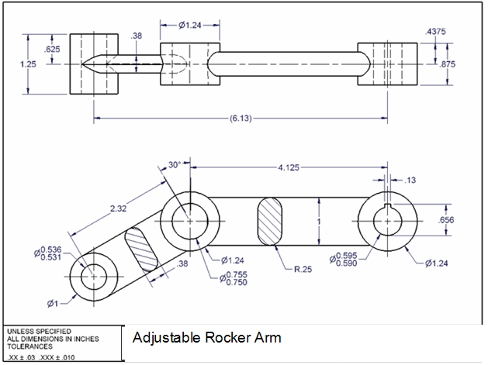

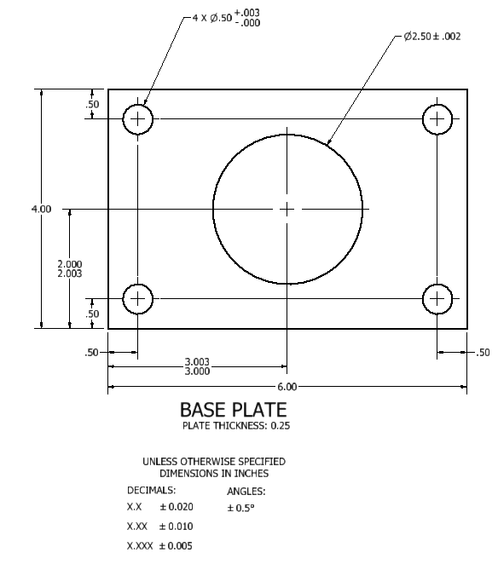

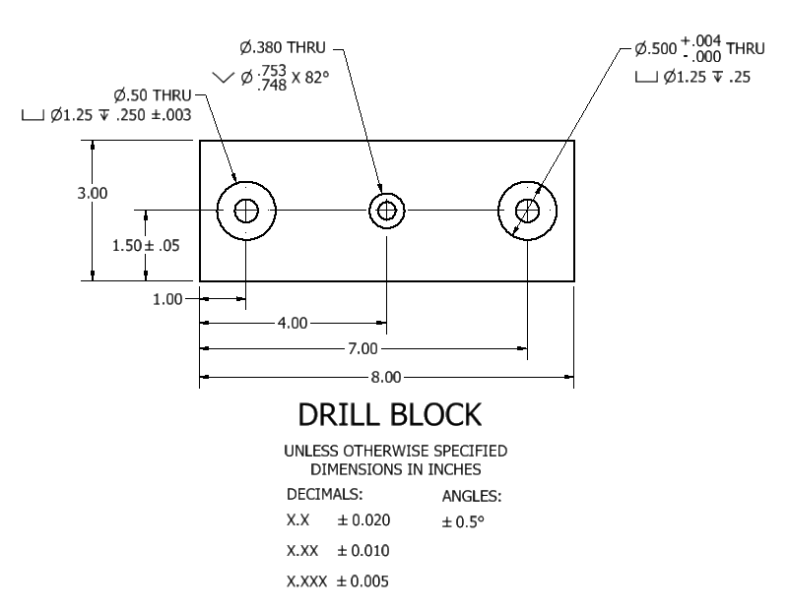
- Consider the adjustable rocker arm represented in the drawing above. An axle is to pass through the smallest hole. The manufacturer is considering buying bar stock for the axle that is manufactured according to the following drawing using the same general tolerances as those specified on the Rocker Arm Drawing. Answer the following questions and SHOW YOUR WORK.
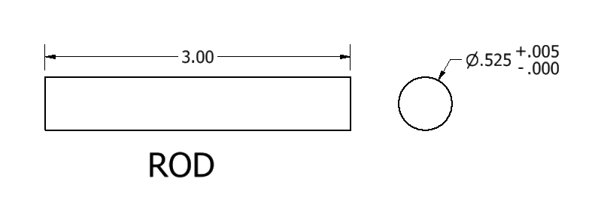

  - What is the tolerance (the acceptable amount of dimensional variation) for the diameter of the rod?

  - What is the tolerance for the rod length?

  - Is the fit between the rod and the hole a clearance fit, interference fit, or transition fit? Explain your answer.

  - What is the allowance between the rod and the smallest hole?

  - If the design of the assembled machine requires that the rod is sized such that the actual clearance between the rod and the hole is never greater than 0.005 inches, will the current rod design meet the requirement? Explain.

  - The machine specification requires that the rod is no longer than 3.025 inches and no shorter than 2.955 in.
    - Let L represent the actual length of the rod. Write the length constraint as a compound inequality.

    - Will the stock rods always meet the length constraint? Explain.

  - If the stock rods do not always meet the machine specifications for rod length, how can the manufacturer alter the rod part drawing such that the rod length will always conform to the specifications?

- Design a rod that will have an interference fit so that the allowance (the maximum interference) is 0.010 with the center hole in the Rocker Arm and the tolerance on the rod diameter is .002. Sketch a section view of your rod design below. Be sure to specify the tolerance in the diameter dimension of your design.

- Consider the axle pin and the body of the Automoblox vehicle (shown below). The axle is designed to remain inserted into the body of the vehicle so that it cannot be removed by a child.
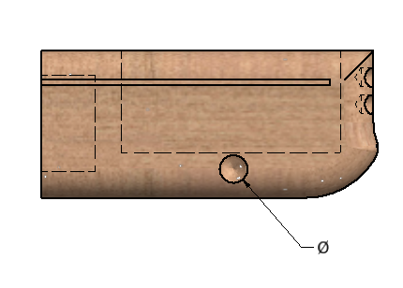
  - What type of fit would you recommend for the axle and body? Why?

  - Assume an interference fit is used and that the ideal interference between the axle and the hole in the body of the vehicle is 0.005 inches. However, the interference can increase to as much as .010 without damage to the parts. With the addition of glue to help adhere the two pieces, an interference of .002 can be used successfully. Assume that the specified diameter of the axle is 0.300 inches as shown on the pictorial above. On the images above indicate your recommendation for:
    - the specific tolerance to the axle diameter dimension
    - the diameter and associated tolerance for the hole in the bed
  - Calculate the following for the exterior axle pin diameter using your suggested dimension tolerances. SHOW YOUR WORK.
Specified dimension: 0.300 inches
Upper Limit: ________________

Lower Limit: _______________

Tolerance: _________________

  - Calculate the following for the diameter of the hole in the body using your dimensioned part drawing. SHOW YOUR WORK.
Specified Dimension: ________________ (if applicable)
Upper Limit: ________________

Lower Limit: _______________

Tolerance: _________________
  - Calculate the allowance between the hole and the axle pin diameter based on your recommended dimensions and tolerances. SHOW YOUR WORK.

- Open the drill block drawing file that you created in Activity 7.2 Sectional Views. The drill block drawing is shown below.
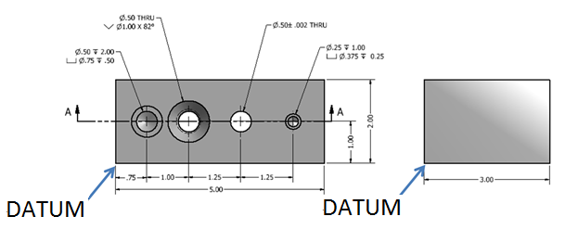
Edit the dimensions to show specific tolerances to the following dimensions. Note that instructions for including tolerance specifications on an Inventor drawing are given below.

  - A bilateral (symmetric) tolerance of 0.10 inches for the overall length, width, and depth.
  - Stack limit dimensions to locate the holes along the depth dimension (2 in.) such that the dimension can vary between the dimension given above and 0.03 inches larger.
  - To better control the hole locations, use datum dimensioning for the dimensions along the long dimension (5 in.). Note that the datum location is shown on the drawing above.
  - A unilateral (deviation) tolerance of +.003 inches for the counter bore diameter on the 0.25 inch diameter hole. Change the precision of the counter bore diameter to show three digits to the right of the decimal place.
  - A bilateral (symmetric) tolerance of 0.002 on the 0.50 inch diameter counter sunk hole.
Add the following General Tolerances notes to the drawing.
Linear Dimensions  X.X = ± .020  X.XX = ± .010  X.XXX = ± .005 | Angles = ± .5°

- Consider the drill block from the question above.
  - If the detail drawing used chain dimensioning to locate the holes along the 5 in. dimension as shown in the image below (and therefore the tolerances are additive), what would be the upper and lower limit of the dimension from the left edge to the center of the 0.25 inch diameter hole on the right (see below) assuming general tolerances apply?
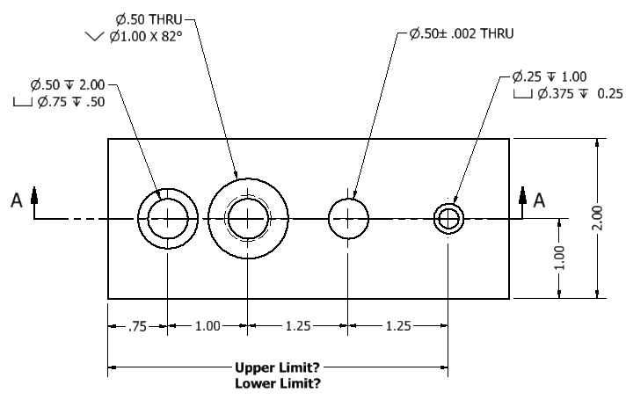

  - What is the upper and lower limit of the dimension from the left edge to the center of the 0.25 inch diameter hole in the drawing you created (using datum dimensioning) assuming general tolerances apply?

Showing Tolerances in Inventor
You can edit dimensions and include tolerances in both a part file and a drawing file. For now, we will simply add tolerances to the drawing (not the part). One option is to simply change the dimension text to include the tolerance. However, it is not possible to add stacked text. A better way to include a tolerance in a dimension or hole is to change the precision and tolerance of the dimension itself.
To include a tolerance in a dimension on a drawing in Inventor.
- Select the dimension.
- Right click and choose Edit.
- Check the Override Displayed Value box.
- Select the Tolerance Method.
- Select the precision (number of decimal places).
- Input the required upper/lower values.
- Depress the OK button.
To include a tolerance in a hole note on a drawing in Inventor.
- Select the hole note.
- Right click and choose Edit Hole Note.
- Depress the Precision and Tolerance button.
- Uncheck the Use Global Precision box.
- Depress the additional options arrow button (bottom right).
- Select the precision (number of decimal places) for each dimension value using the drop-down menus.
- Use the check boxes to choose the dimension to which you will add a tolerance. Choose the tolerance method and precision of the tolerance value(s).
- Depress the OK button.

Conclusion
- Why do engineers place tolerances on dimensions?

- What are the three types of tolerances that appear on dimensioned drawings?

- What is the difference between a general and a specific tolerance, and how can you tell the difference on a drawing?

