Project 4.1.1 Wind Turbine Design

Introduction
Wind turbines populate the landscape in many parts of the world. These systems harness naturally abundant wind and transform it into electrical energy. Turbine blades efficiently convert wind energy into a force which turns a wind turbine. This energy conversion is an application of aerospace engineering principles. In this project you will research and design wind turbine blades, then you will design and build your own turbine.
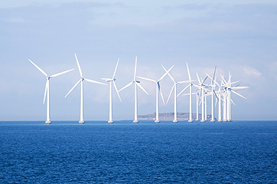

Equipment
- Computer with access to research resources
- Plywood or similar base approximately 12 in. x 12 in.
- Basic Turbine Building Parts:
      - KidWind Hub
      - Dowels
      - Wind Turbine Generator
- Hook up wires
- Box fan or similar (one per class)
- 1 in. PVC pipe (8 in.)
- 1 in. PVC pipe plug
- 1 in. PVC coupler
- 1 in. PVC 90 degree elbow
- Various materials to build wind turbine blade and attachment mechanism
- Multimeter (one per class)
- Engineering notebook
Procedure
- Divide into groups of two under your teacher’s direction.
- Research wind turbine blade design.
- Build the turbine test stand
  - Attach a 1 in. PVC pipe plug to a base using a wood screw similar to image shown below. Attach a 1 in. PVC coupler to the plug.
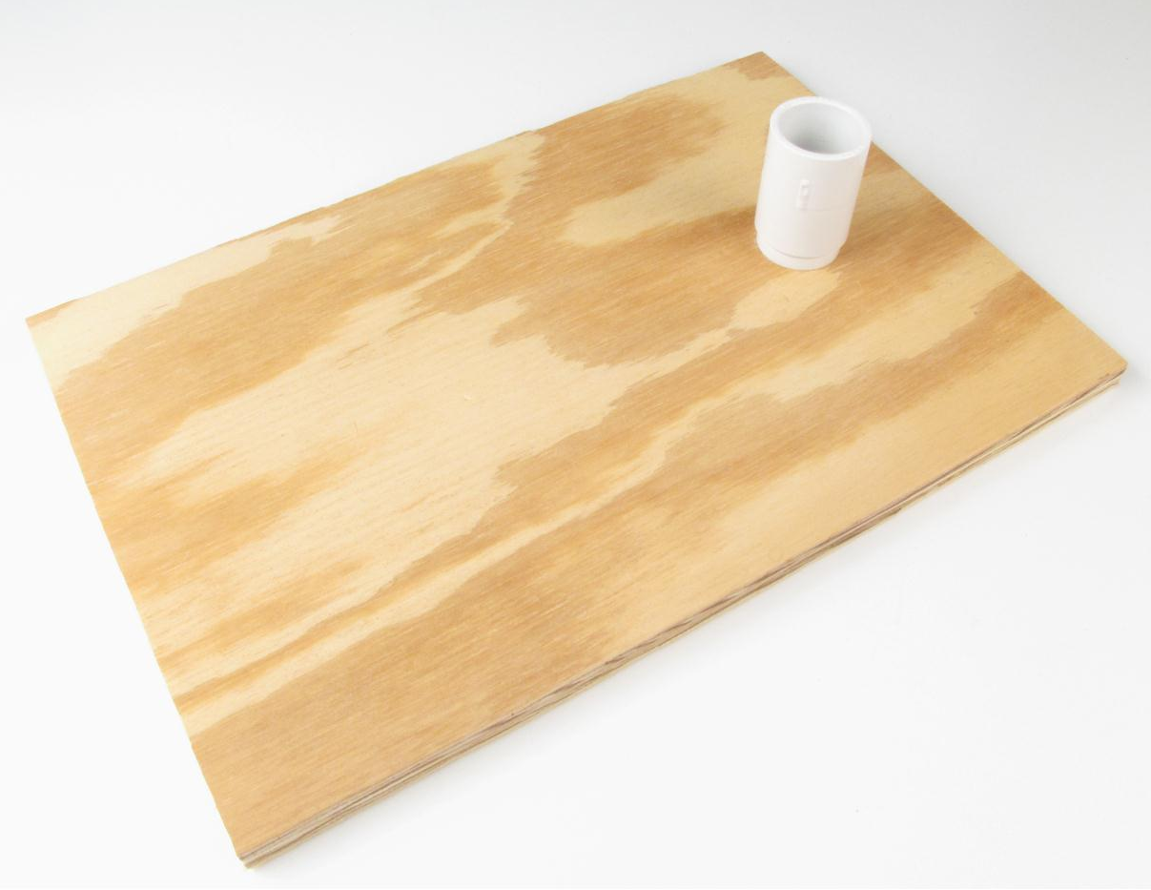
Wind Turbine Base
  - Drill a ¼ in. hole in the elbow. Wires from the motor will pass through this hole. Attach a 1 in. PVC pipe (8 in.) to the coupler then attach a 1 in. PVC 90 degree elbow to the pipe. Carefully thread the pancake motor wires through the elbow hole while inserting the motor into the elbow. Attach KidWind Hub and dowels as shown below.
 | 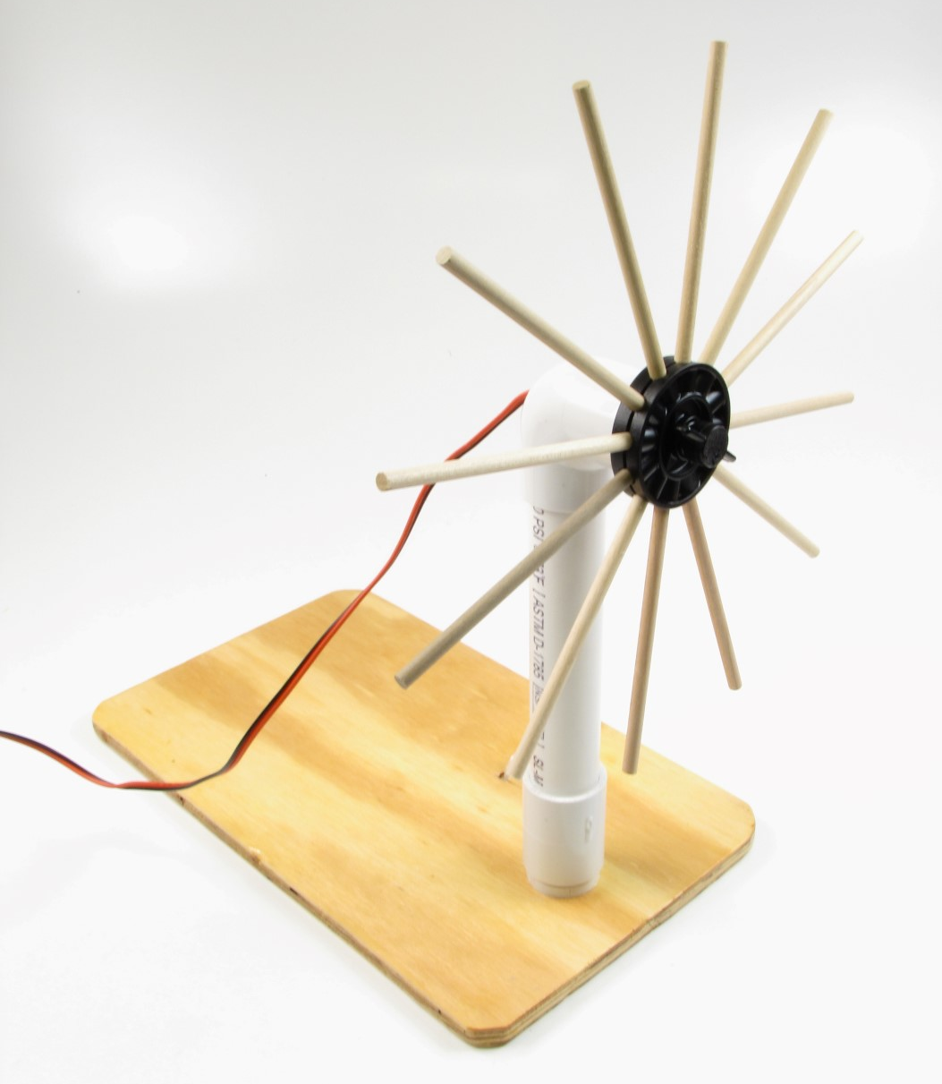
90 Degree Elbow with Hole | KidWind Hub and Motor Installed

- Build the turbine and attach it to the motor shaft.
- Test the turbine.
  - Set up the multimeter to measure DC Voltage.
  - Connect the multimeter leads to the motor leads.
  - Power on the multimeter.
  - Start the fan on the lowest setting to turn your turbine.
  - Record the voltage.
  - Run the fan at various speeds up to the maximum. Record the voltage at each speed.
  - Plot the speed versus voltage.
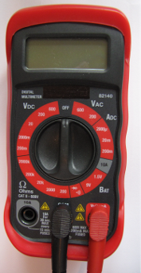
Multimeter

Conclusion
- Describe the strengths and weaknesses of your turbine design.
- Explain what would improve your turbine design.

