Activity 3.2.7 Systems Tool Kit

Introduction
Launching satellites and space vehicles is an expensive activity. The risks are high and the rewards are even higher. Reducing the risks is a major objective of any organization planning to launch vehicles into space. A tool available to planners is software such as the Systems Tool Kit (STK).

In this activity you will learn how to model an orbiting satellite and ground-based tracking stations.

Equipment
- Engineering notebook
- Notes from Systems Tool Kit presentation
- Computer with STK software

Procedure
- Launch the STK software.
- Confirm that an active STK license is installed.
  - Click Help, and then License Viewer.

  - Confirm that the License Viewer display shows multiple licenses including STK, similar to the image below.
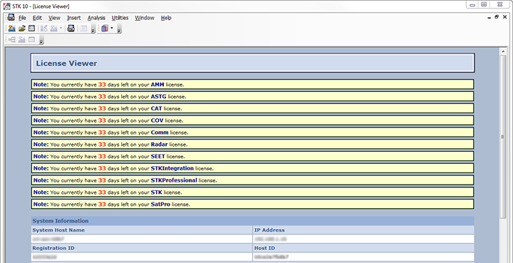
  - If the License Viewer window shows multiple No License Found messages similar to the image below then a PLTW license needs to be installed so report this to your teacher.
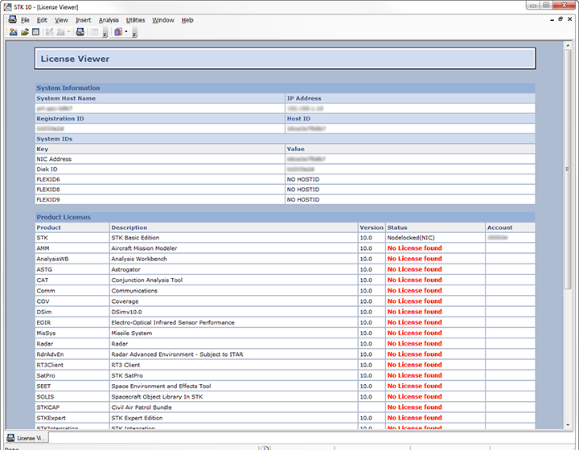

- Select Help on the pop up, or if STK is already open, click Help and then STK Help.
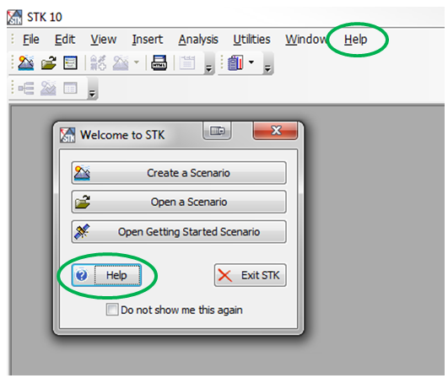
- Select Get Started, Tutorials, STK, and then select STK Quick Start.
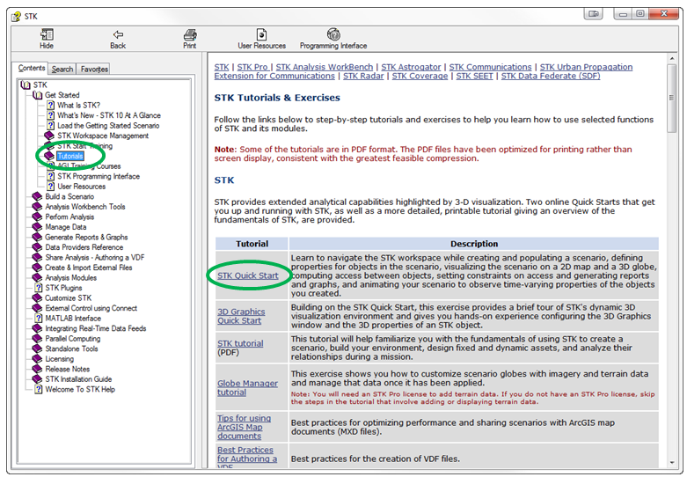

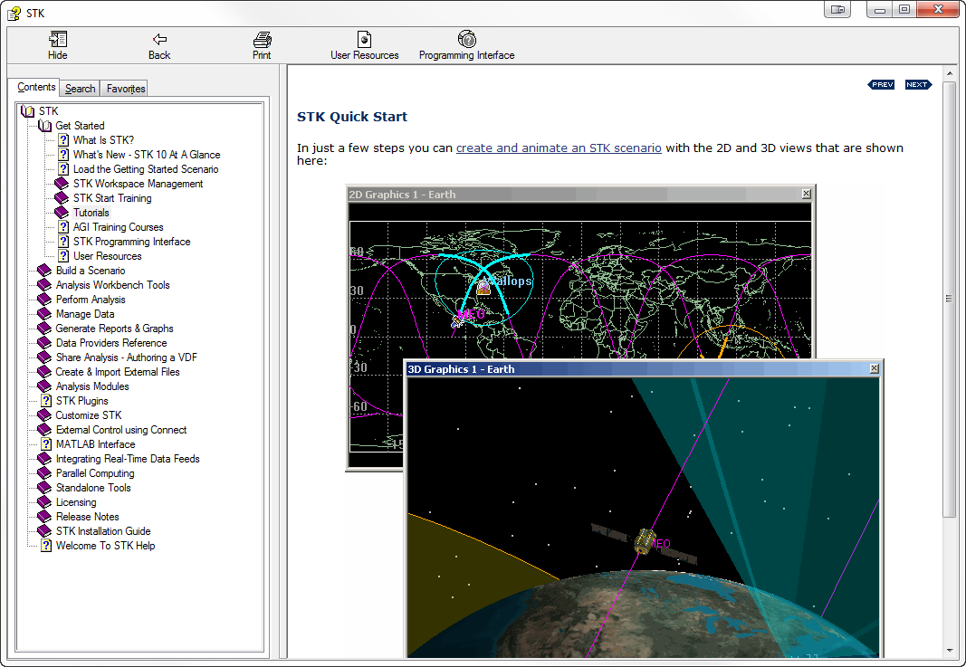

- Perform the steps in this tutorial. The last step is titled Create Reports & Graphs. Your display should resemble the image that follows.
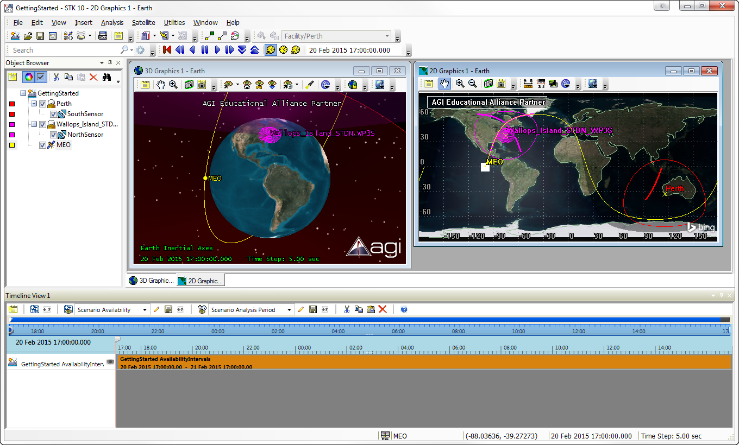
- Capture a screen image and insert it into your engineering notebook.

Conclusion Questions
- What scenario can you envision the STK software modeling?
- What limitations do you suspect this software might have for modeling a scenario?
- What organizations might use this software?

