Activity 3.2.5 Orbital Mechanics Modeling

Introduction
Aerospace engineers design satellite orbits to suit the unique requirements of the mission. The orbit is described with six parameters to cover an area on the ground aligned with the mission.

In this activity you will apply your knowledge of orbital mechanics to describe the orbit of a satellite based on its ground trace. You will also use Analytical Graphics, Inc. (AGI) Orbit Tuner application within the Systems Tool Kit software to adjust the orbit of a satellite to achieve a mission objective.

Equipment
- Engineering notebook
- Notes from Orbital Mechanics Models presentation
- Computer with STK software
- 3.2.5.A OrbitTuner.zip file

Procedure
- Determine the inclination and period of the satellite which produced the ground trace below. Show all calculations.
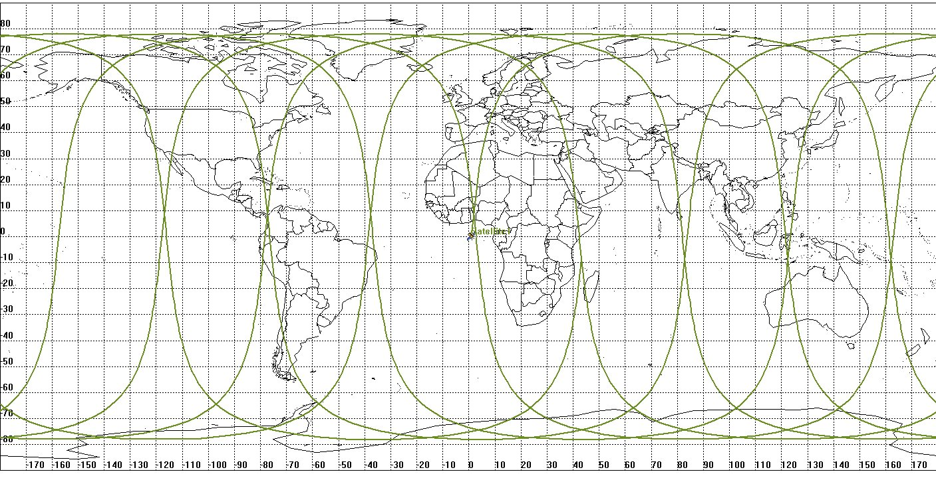

- Determine the inclination and period of the satellite which produced the ground trace below. Show all calculations.
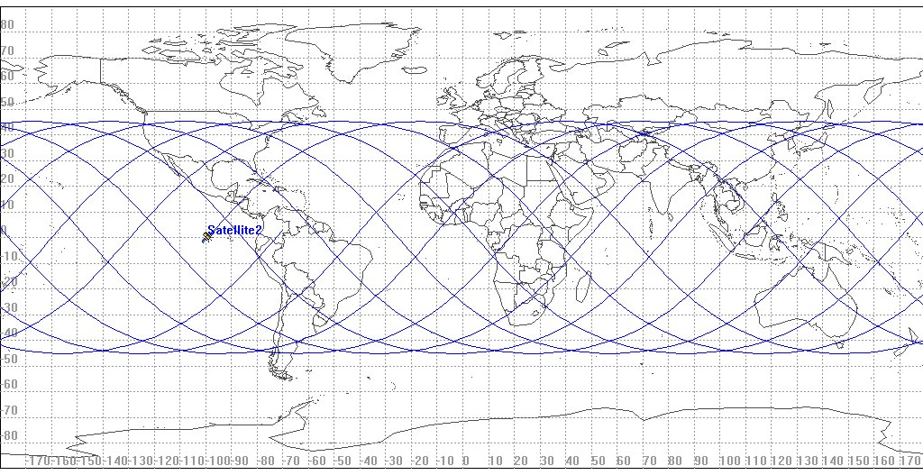
- Watch the Orbit Tuner tutorial video.
- Start the Orbital Tuner application using the option specified by your teacher.
  - Copy 3.2.5.A OrbitTuner.zip into an accessible area on your computer and unzip it.
  - Double click on Orbit_Tuner_v2.10.exe file.
  - The STK logo pop-up will appear then the Orbit Tuner software will appear as shown below.
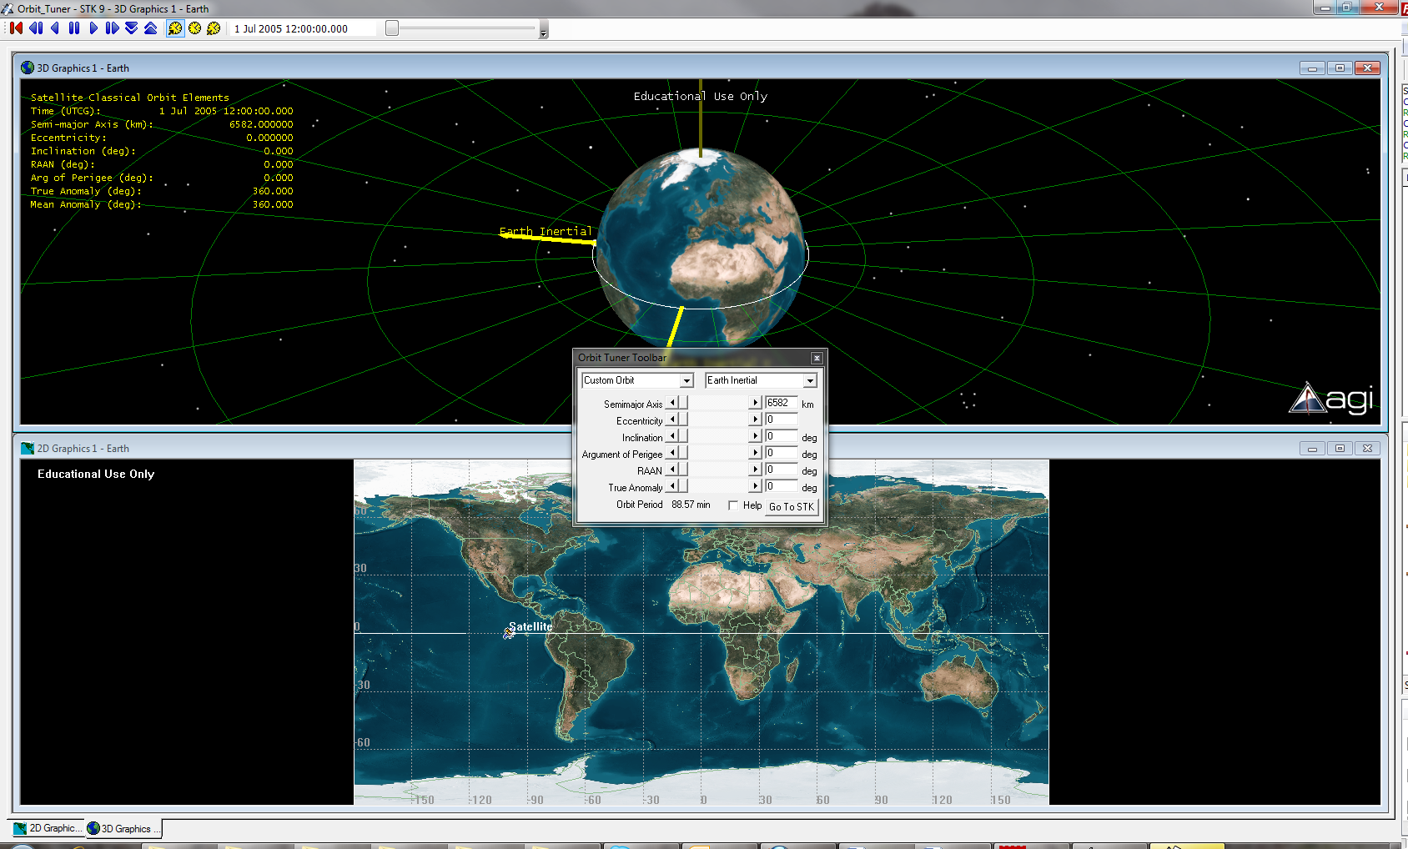
Orbit Tuner using Systems Tool Kit, STK, Software
- The government of Ecuador has contracted your organization to place a communications satellite in orbit over the city of Quito to prepare for a potential earthquake threat in the region. You are the aerospace engineer tasked to design the orbit to fulfill the mission requirements.
- The University of New Brunswick in Canada was awarded a grant from the Department of the Environment to study the thinning of the northern polar ice cap in an effort to quantify global warming. The imaging system to monitor the ice thickness will be carried on the Polar Sheet satellite to be launched this spring. Design the orbit of a satellite to maximize oversight of this region.
- Create a detailed mission description. Use the Orbit Tuner software to design the orbit to complete the mission, create a print screen of the solution, and document why this orbit fulfills the mission.
- Exchange your mission description with another student.
- Design the orbit to fulfill the mission assigned to you by another student.
- Discuss your solution with the student who designed the mission and come to an agreement on the final design.
- Reverse roles and follow the process described in the previous steps.

Conclusion
- Explain why the period affects the usefulness of the satellite.
- Explain the impact of the six parameters on the ground trace.

