Activity 2.1.3 Frame Generator Analysis

Introduction
Frame construction is used throughout the aerospace industry in the creation of welded steel-tube fuselages, piston-engine motor mounts, ribs, and landing gear. In this activity, you will gain understanding of the frame analysis built into Autodesk® Inventor® software.

Equipment
- Computer with Autodesk Inventor software
- Inventor Data Set Tutorial File from myPLTW LMS

Procedure
- Start the Autodesk Inventor software.
- In a convenient file location on your computer, create a new single-user project named Activity_2_1_3_FrameGeneratorAnalysis and set this as the default project.
- Download and unzip 2.1.3.A FrameGeneratorAnalysisFolder.zip from the myPLTW LMS course.
- Move the files unzipped in the previous step into the new project folder.
- In the top-right corner, select the Help icon.
The Autodesk Inventor 2016 Help website opens.

- In the Contents panel click the plus sign icon beside Tutorials, and then click Tutorial Archive. In the main view, click Autodesk Inventor Tutorials as shown below.
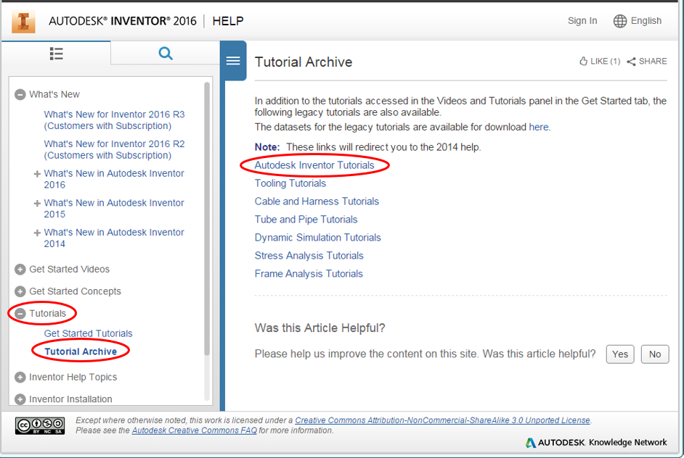
- A new web page opens for Autodesk Inventor 2014 Help.
- In the Contents pane, scroll down to the Frame Analysis Tutorials and click the plus sign icon beside it. Click the plus sign icon beside Frame Analysis.
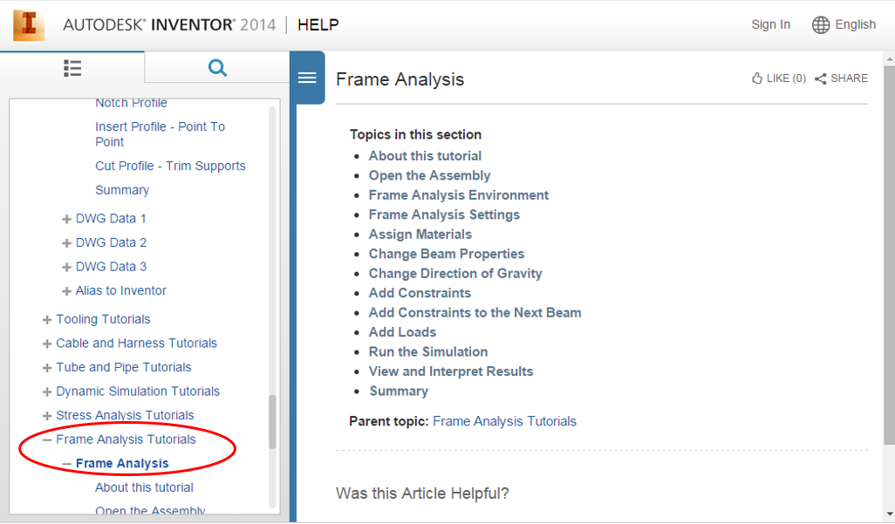

- In the main view, click Open the Assembly.
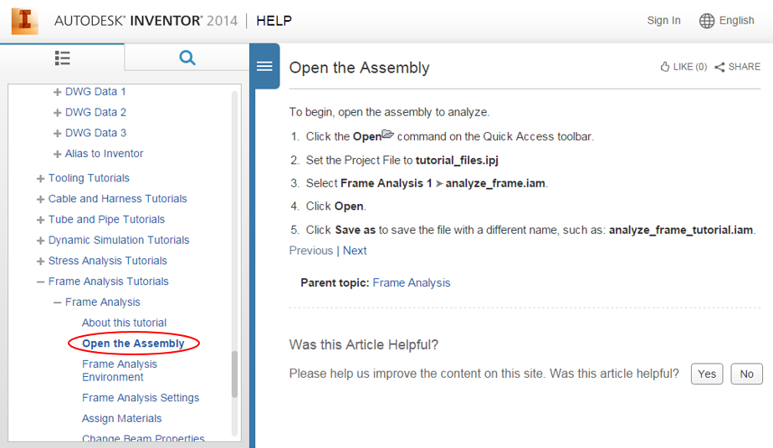
- Complete each step of the Frame Analysis tutorial by clicking click Next to continue to the next step until you get to Summary. If necessary, you can use the folder structure in the Contents pane to go to a specific part of the tutorial.
- Stop when you have completed the Summary step.
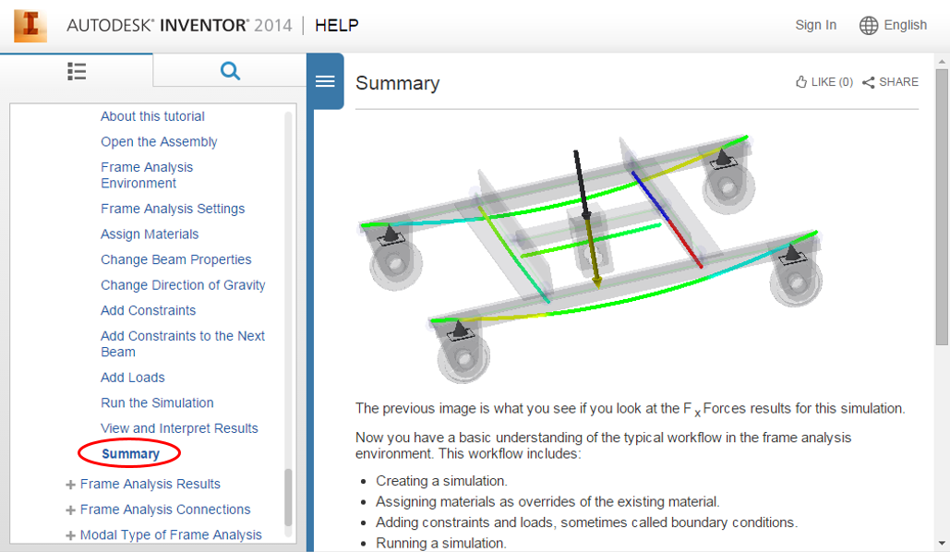
- Show to your teacher that you have completed the tutorial.
Conclusion
- List three functions that the Frame Analysis tool provides and describe how they relate to aerospace design.

