Activity 2.1.2 Frame Generator Introduction

Introduction
Frame construction is used throughout the aerospace industry in the creation of welded steel-tube fuselages, piston-engine motor mounts, ribs, and landing gear. In this activity, you will gain understanding of the frame generator function included in the Autodesk® Inventor® software.

Equipment
- Computer with Autodesk Inventor software
- Inventor Data Set Tutorial File from myPLTW LMS

Procedure
- Start the Autodesk Inventor software.
- In a convenient file location on your computer, create a new single-user project named Activity_2_1_2_FrameGenerator and set this as the default project.
- Download and unzip the file named 2.1.2.A FrameGeneratorFile.zip from the myPLTW LMS course.
- Move the frame_generator.ipt file unzipped in the previous step into the new project folder.
- In the top-right corner, select the Help icon.
The Autodesk Inventor 2016 Help website opens.

- In the Contents panel click the plus sign icon beside Tutorials, and then click Tutorial Archive. In the main view, click Autodesk Inventor Tutorials as shown below.
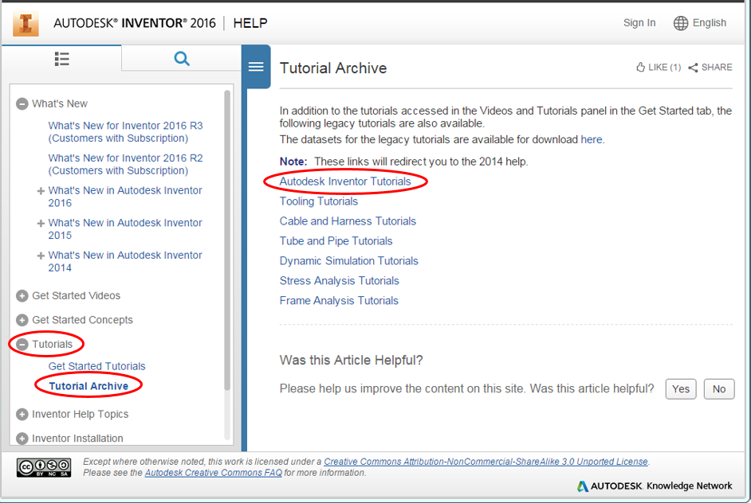
- A new web page opens for Autodesk Inventor 2014 Help.
- In the Contents pane, scroll down to Frame Generator and click the plus sign icon beside it. Click Skeletal Model.
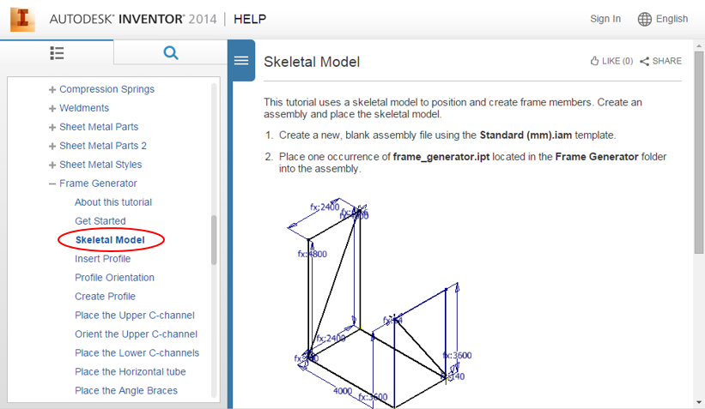

Note: For more information about the Frame Generator tool, click the plus sign icon beside Inventor Help Topics, then click Assemblies and Frame Generator.
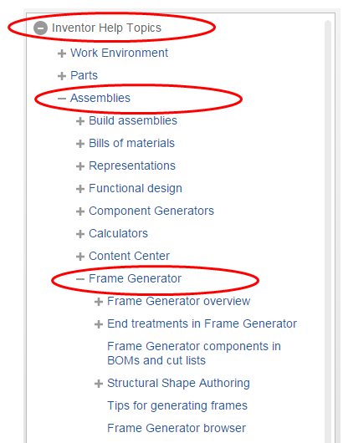
- When you complete each step of the Frame Generator tutorial click Next to continue to the next step until you get to Modify the Skeleton. If necessary, you can use the folder structure in the Contents pane to go to a specific part of the tutorial.
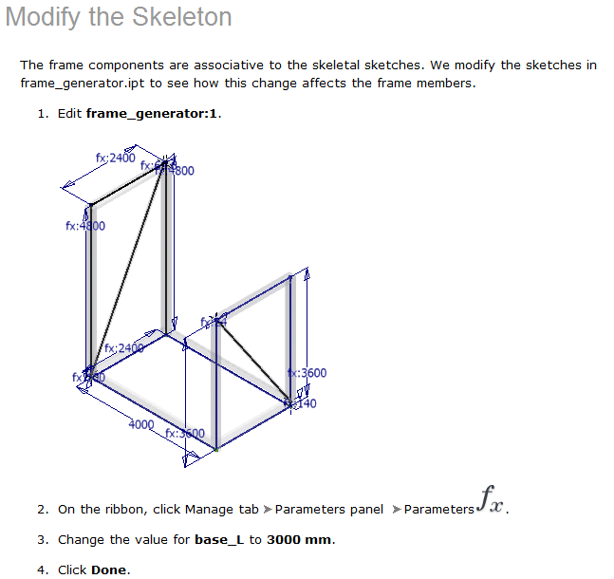
- Show to your teacher that you have completed the tutorial.
Conclusion
- Describe the benefits of using the Frame Generator when creating frames.
- Describe aircraft components that could be created using the Frame Generator.

