Activity 1.3.5 GPS Navigational Chart Creation

Introduction
GPS technology allows for precise location data logging including data sets relating to time, longitude, latitude, and altitude of the GPS unit. GPS handheld units, such as the Garmin product, can be used to log and export location data sets with ease. Exported location data sets can be applied, using mapping software such as BaseCamp or MapSource, to 2D or 3D maps and charts to create data reinforced situational awareness.
During the next three activities you will create a detailed navigational chart; design a route and then another group will navigate that route.
In this activity you will use mapping software and location data logged from a handheld GPS unit. Location data and detailed waypoint information will be collected during a teacher-led tour of the mapping area.
The mapping area is an outdoor area that has been defined by your teacher. Within the area are numerous objects that represent either reference locations or obstacles that must be avoided during routine passage through the airspace. Your teacher will identify the objects, which are surface features, physical objects, or locations of interest.
Equipment
- Handheld GPS Unit
- USB cable for GPS unit
- Computer with Garmin BaseCamp™ or Google Earth Software
- GPS owner’s manual
- Engineering notebook

Procedure
- Obtain handheld GPS Unit and owner’s manual from your teacher on from the manufacturer’s website.
- Identify the buttons and functions below on the GPS unit. Read the description of each button’s function in the owner’s manual. A Garmin eTrex Venture ® is shown below as an example.
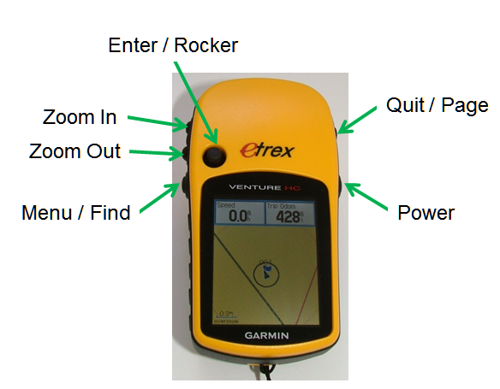

- Become familiar with capturing waypoint information using the GPS unit.
The Garmin eTrex Venture® HC GPS unit provides two methods for capturing a waypoint. The first method, instantaneous sampling, records a location at a moment in time, while the second, average sampling, accumulates data over a period of time. In this activity you will perform both methods of capturing waypoint location information.

Instantaneous Sampling identifies a GPS unit’s location at a specific moment in time based on constantly updated satellite information calculations. The GPS unit captures its current location or waypoint at the exact moment in time specified by the GPS unit user, typically initiated by a momentary pressing of an interface button. Instantaneous sampling provides low quality location information because object position is limited to that the specific moment in time the GPS unit logged the data.

Procedure:
  - Press and hold the Enter until the Mark Waypoint page appears
  - Highlight OK
  - Press Enter

Averaging Sampling (Sampling over Time) identifies a GPS unit’s location based on numerous data points collected over a period of time. With each data point collected, random errors are diminished and the final location data becomes more accurate because it is based on the average of the logged data. To create reliable location data the GPS unit must remain fixed and unmoving for the entire duration of the data collection period.

Procedure:
  - Press and hold the Enter until the Mark Waypoint page appears.
  - Highlight Avg
  - Press Enter
  - Collect data for one minute
  - After one minute press Enter to save the waypoint

Activity Data Collection - Although the Garmin eTrex Venture® HC GPS unit is capable of recording a text label for a waypoint, it is much faster to record the waypoints in numerical order and then label them later when you create the navigational chart. Complete the activity data recording form as you collect the waypoint data.
- Participate in teacher led mapping area tour.
- Draw a rough sketch of the mapping area in your engineering notebook with waypoints that you intend to record.
- Record waypoint location data for each waypoint within your mapping area on the Waypoint Identification Table. Be complete and accurate. For the first 10 measurements, you must use the averaging method and record the time required to achieve an estimated accuracy of 20 feet.
- Draw a team member’s initials on the map.
- Clear the tracks indicated on the GPS unit.
- Press the Menu button until the Main Menu page is displayed.
- Use the Rocker to highlight the Tracks and then press Enter.
- Highlight the Save button and press Enter.
- Highlight the Delete button and press Enter. Confirm the deletion.
- Place GPS in track mode.
- Slowly walk through spelling out the initials.
- Connect GPS unit to PC to upload GPS waypoint data.
- Start Mapsource mapping software.
- Upload data.
- Zoom to a scale of 80 feet.
- Adjust preferences to view specific waypoint information
  - To adjust Preferences, select Edit, then Preferences. Select Waypoint, Display, and Symbol & Comment
  - Waypoint Categories
    - Boundary
    - Obstacle
    - Start
    - Turn
    - Cache
- Create navigational chart of mapping area
  - Confirm that the map is displayed in the 80 foot scale.
  - Import the Mapsource data into Google Earth software and zoom to an appropriate level.
  - Use SnagIt or other screen capture software to make an image of the Google Earth display. Save this image as a base map.
  - Re-label waypoints to the appropriate label according to the map area tour.
  - Confirm that the map is displayed in the same scale as before. Use the capture software to make an image of the Google Earth display. Save this image as a navigational chart.
  - Print this navigational chart.

Waypoint Identification Table
Waypoint | Type | Longitude |  |  | Latitude |  |  | Method  I or A(x)
 |  | Direction | Degrees | Minutes | Direction | Degrees | Minutes
 |  |  |  |  |  |  |  | ( )
 |  |  |  |  |  |  |  | ( )
 |  |  |  |  |  |  |  | ( )
 |  |  |  |  |  |  |  | ( )
 |  |  |  |  |  |  |  | ( )
 |  |  |  |  |  |  |  | ( )
 |  |  |  |  |  |  |  | ( )
 |  |  |  |  |  |  |  | ( )
 |  |  |  |  |  |  |  | ( )
 |  |  |  |  |  |  |  | ( )

Waypoint Identification Table (Page 2)
Waypoint | Type | Longitude |  |  | Latitude |  |  | Method  I or A(x)
 |  | Direction | Degrees | Minutes | Direction | Degrees | Minutes

Conclusion
- What is a waypoint? How are they typically used? How can they be used to create a navigational chart?
- How accurate is a GPS unit at providing a location for an object?
- What is the method used to capture location data with your GPS? How do you upload the data to your computer, modify the map, and print out a chart?
- Are you confident that you understand your GPS unit and the data collection process? If not, what questions need to be answered or what experiences do you need now so that you will be able to complete future activities?

