Activity 1.3.2 Flight Simulator Introduction Joystick Configuration
Joystick Configuration  This configuration guide is for the Logitech Extreme 3D Pro Joystick. | 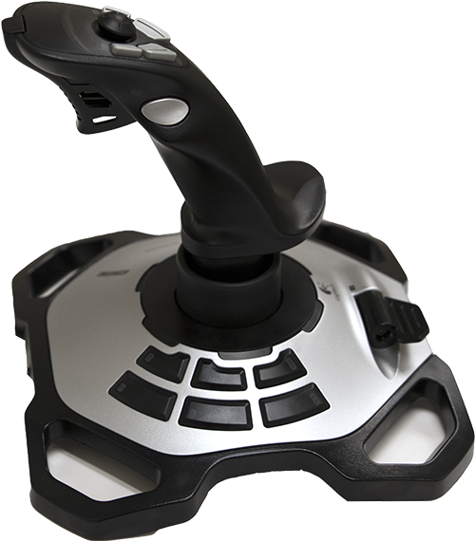
 | Logitech Extreme 3D Pro Joystick

Button | Function | Button | Function
1 |  | 9 | Rudder trim left
2 | Pause the simulation | 10 | Rudder trim Right
3 | Pitch trim down | 11
4 | Flaps down a notch | 12 | Toggle brakes maximum effort
5 | Pitch trim up | Hat switch forward | View: fwd no HUD
6 | Flaps up a notch | Hat switch reverse | View: Chase
7 | Aileron trim left | Hat switch Left | View: glance left
8 | Aileron trim right | Hat switch right | View: glance right
 |  | Trigger | Toggle Brakes Regular Effort
The joystick has labeled buttons 1 through 12. Note any references to button numbers are the physical button labels. The button numbers within Fly To Learn Powered by X-Plane will not match.

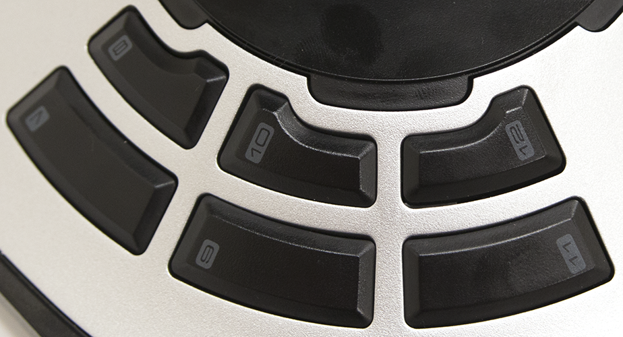 | 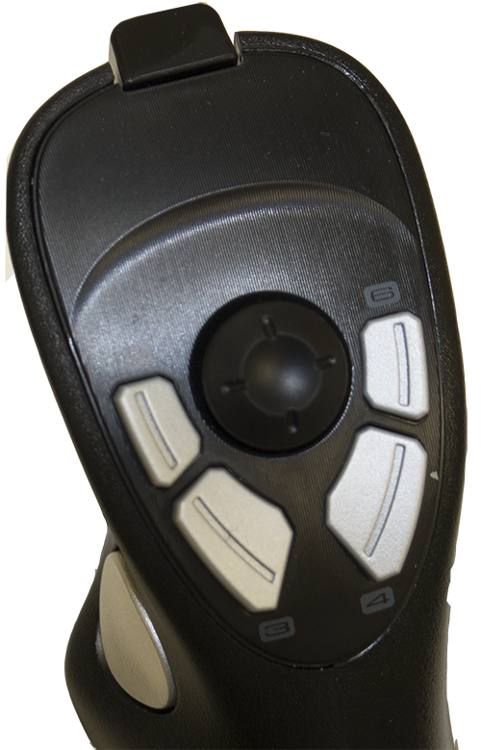
Buttons 7-12 | Buttons 1-6, Trigger and Hat Switch

Joystick Calibration
Set up a joystick in Fly To Learn Powered by X-Plane. Select Joystick, Keys & Equipment under the Settings menu. The menu shown only appears when the cursor is near the top of the window.

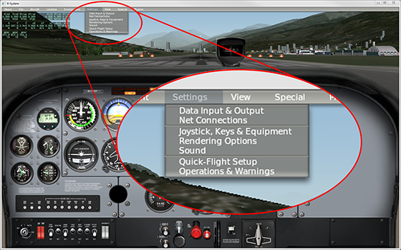

Calibrate the full extent of each axis on your joystick with window. Select Calibrate Joystick Hardware to begin the calibration process. Move the joystick through the full extent of each axis including the twisting the joystick and moving the throttle at the base of the joystick.

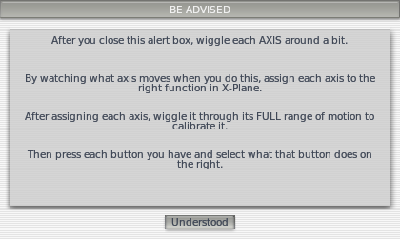
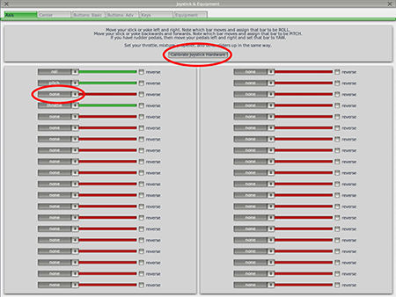

Joystick Calibration
Move the joystick in each of the axis to see the response in the Axis window. Change the drop down beside each of the associated axis to be pitch, roll, yaw, and throttle. Move the joystick forward and backward to control pitch. Move the joystick left and right to control roll. Twist the joystick forward and backward to control yaw. Move the throttle at the base of the joystick forward and backward to control the throttle.

Button Assignments
Assign buttons on the joystick. Select Buttons: Basic.

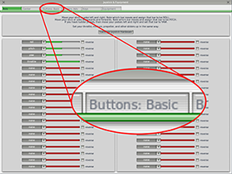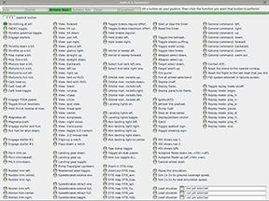

All of the basic functions available in X-Plane will be displayed. The first button displayed will be 000. Click any button on your joystick to see the assignment for that button. Click button 2 close to the top of the joystick. X-Plane reads this as button number that depends on your installation process. Assign button 2 to Pause the simulation.
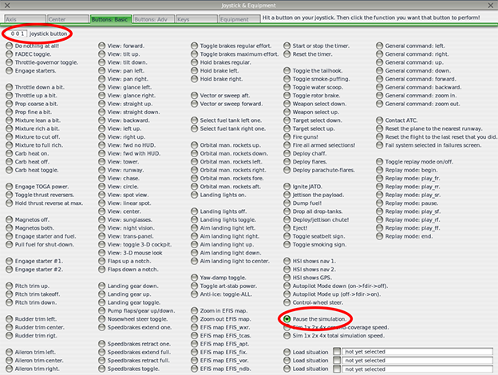

Use the button assignment table shown on the first page to assign the remaining joystick buttons. Keep the joustick assignment table button available as a reference while you are flying. When you are finished assigning buttons then select the lower of the two X icons to close the Joystick & Equipment window and avoid closing the Fly To Learn Powered by X-Plane software. Consider printing the first page to have available as a reference.

