Problem 1.2.2 Aircraft Trim Design Challenge

Introduction
Aircraft control is crucial for a safe and effective flight. Recognizing the importance of designing an aircraft that could fly predictably and also be controlled was an important factor in the success of Orville and Wilbur Wright’s first flight and for aircraft that built upon that learning. An important complement to an aircraft control surface is aircraft trim features. These features allow the aircraft flight characteristics to be predictably adjusted, reducing the need for the aircraft control surfaces to be moved.

In this problem you will apply your knowledge of aircraft performance factors to design and test aircraft models to accurately complete flight challenges.

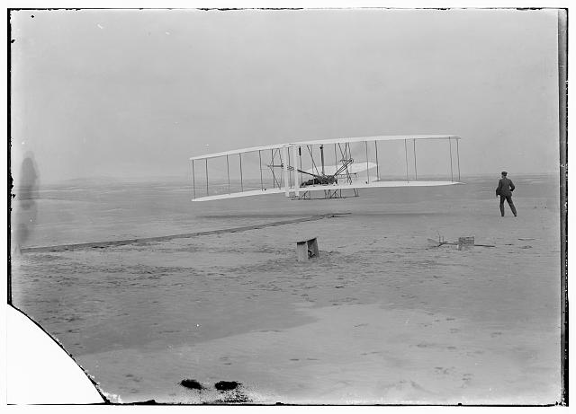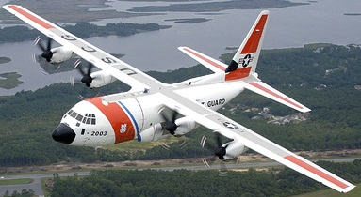

Equipment
- Engineering notebook
- 8½ in. × 11 in. paper (1 piece per student)
- 11 in. × 17 in. paper (optional)
- 2 bars such as a 2 × 4 × 4 ft piece of wood or flagging tape
- Objects to support two bars approximately 3 ft above ground
- Measuring tape

Procedure
- Write your name on a corner of one sheet of 8½ in. × 11 in. paper. This will be the only aircraft model material that you will use to complete the flight challenges.
- Use the engineering design process to design and build an aircraft model which will accurately complete each of the flight challenges in the sequence shown below while applying the following constraints:
  - Constraints
    - Your aircraft can be propelled with the motion your hand while you stand on the ground at the designated launch position.
    - Your aircraft can be built from the single sheet of 8½ in. × 11 in. paper which you were assigned at the beginning of the problem.
    - If the single sheet of 8½ in. × 11 in. paper becomes damaged or you determine that it is not useable then you can use a new sheet of paper and restart the flight challenges from the beginning.
    - Since your aircraft cannot be controlled after it is launched the aircraft must be designed so that its trim characteristics are established by bending or folding the paper without tearing it.
  - Procedure
    - Document your design process and flight performance observations in your engineering notebook.
    - Follow the direction from your teacher for access to testing your aircraft before the evaluation flight test.
    - The evaluation flight test must be witnessed and initialed by the teacher.
    - The aircraft must have an initial or other designation on the aircraft for the challenge to be officially completed.
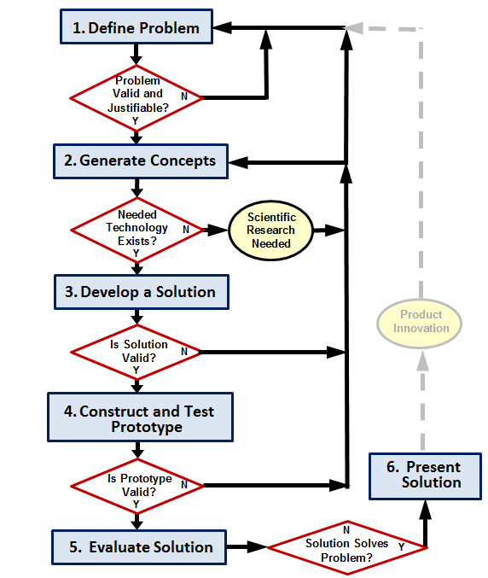

- Perform the challenges shown in sequence.
Challenge 1: The aircraft must fly from the launch position to an area marked at 30 ft away and above 42 in. from ground.
Challenge 2: The aircraft must fly from the launch position to 3 ft away and turn 90 degrees to the left.
Challenge 3: The aircraft must fly from the launch position to pass under the first horizontal bar positioned approximately 3 ft from the launch position and approximately 3 ft above the ground. The aircraft must then continue to fly over the next bar located approximately 3 ft from the first horizontal bar and approximately 3 ft above the ground.
Challenge 4: Complete challenge 1 again.
Challenge 5 (optional): Complete challenge 1 using one sheet of 11 in. × 17 in. paper.
- Answer the reflection questions below in your engineering notebook.
  - If you were to coach another student what advice would you share with the student who is struggling to complete a challenge?
  - What would you describe as an important consideration to design an effective trim feature?
  - How would you approach a similar challenge in the future to apply the design process more efficiently?
- Submit your engineering notebook with your aircraft that contains the markings indicating the completion of each challenge.

